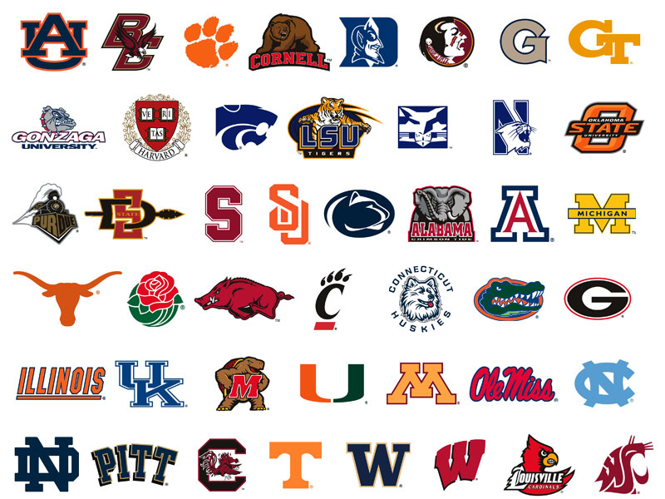

COLLEGE PLANNING TIMELINE

